**Module – 2 ASSIGNMENT**

**Data Types**

**Please implement it by using Python.**

1. Construct 2 lists containing all the available data types (integer, float, string, complex and Boolean) and do the following..
   1. Create another list by concatenating above 2 lists
   2. Find the frequency of each element in the concatenated list.
   3. Print the list in reverse order.

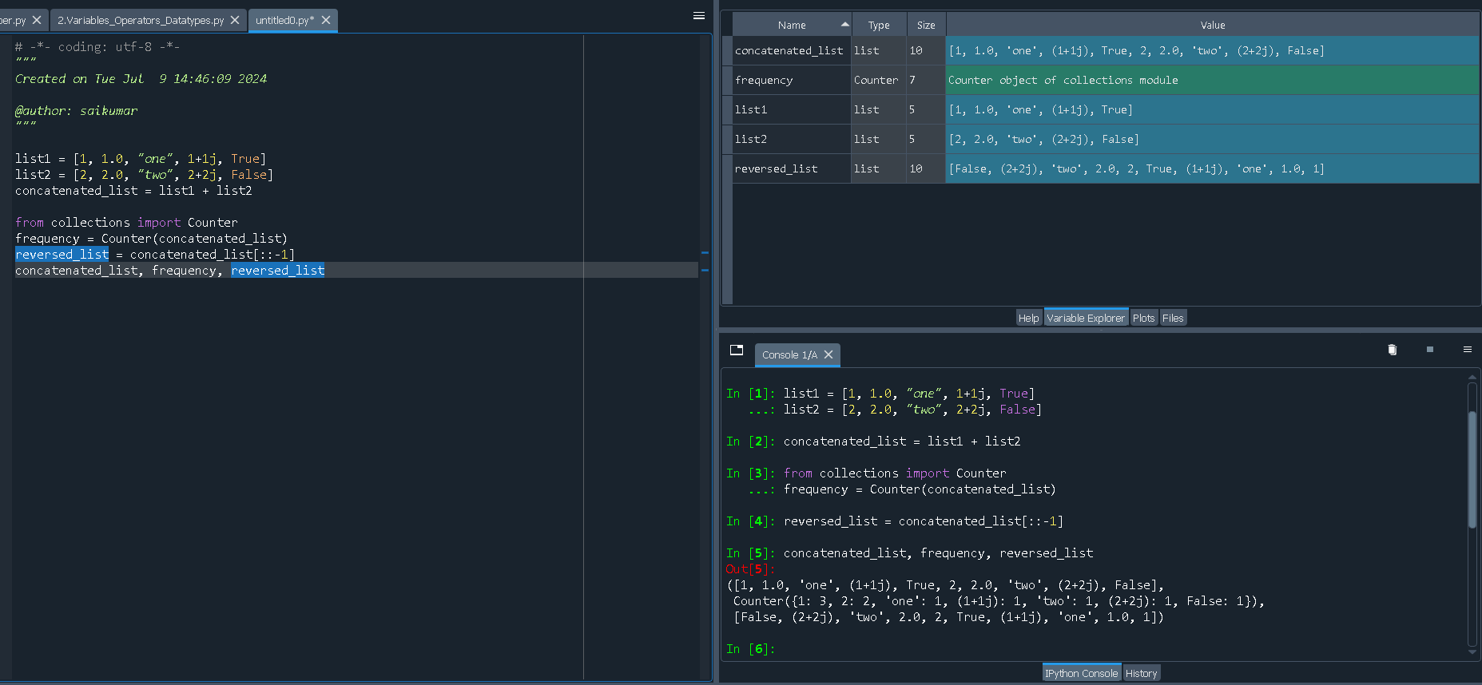

1. Create 2 Sets containing integers (numbers from 1 to 10 in one set and 5 to 15 in other set)
   1. Find the common elements in above 2 Sets.
   2. Find the elements that are not common.
   3. Remove element 7 from both the Sets.

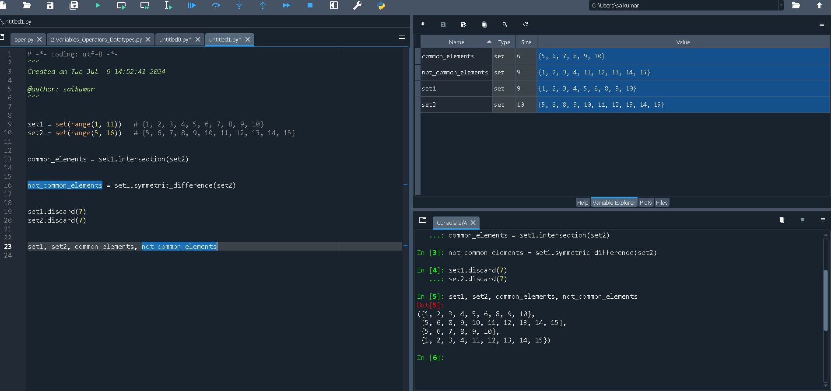

1. Create a data dictionary of 5 states having state name as key and number of covid-19 cases as values.
   1. Print only state names from the dictionary.
   2. Update another country and its covid-19 cases in the dictionary.

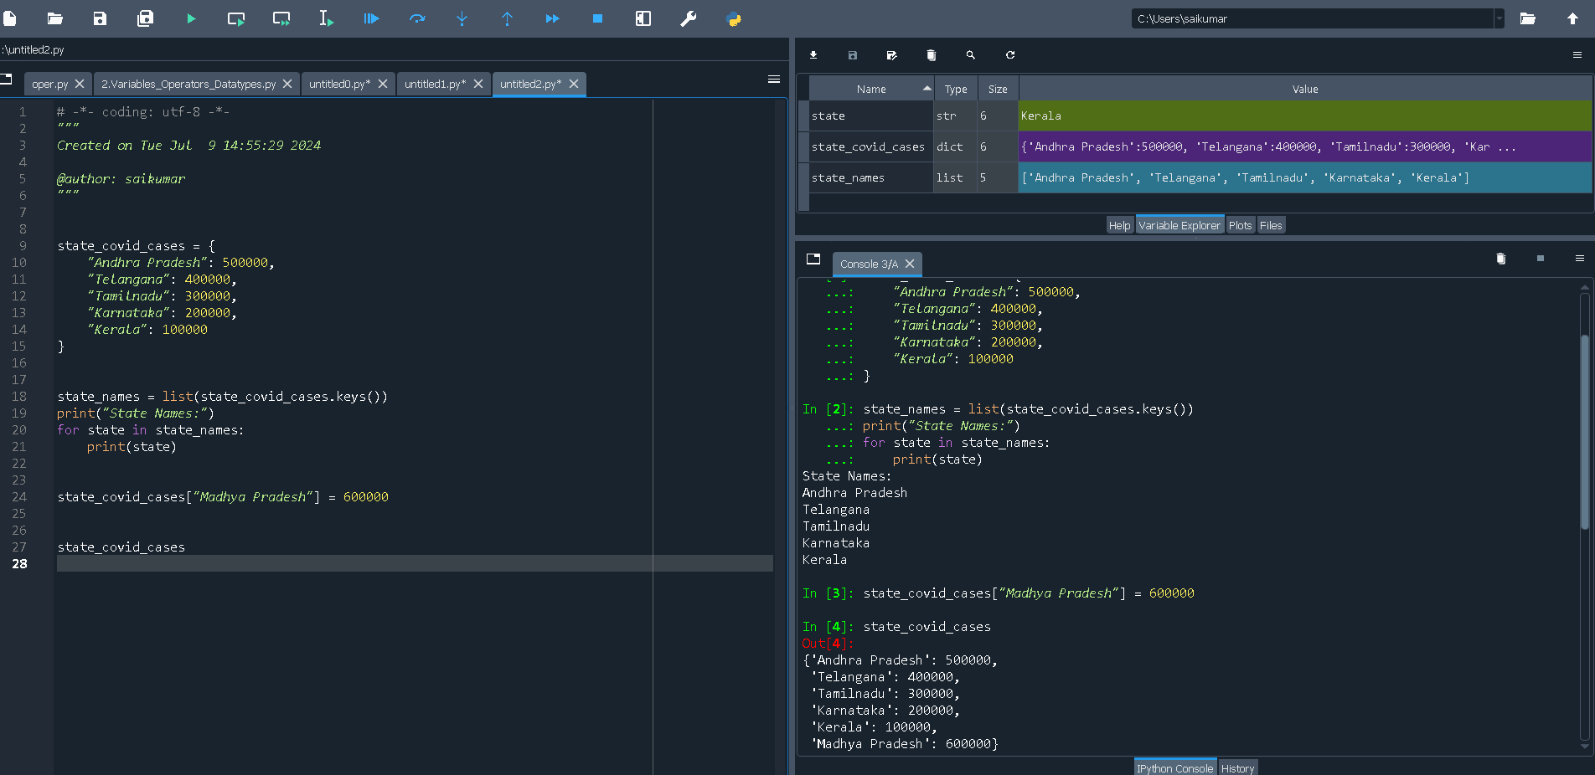

**Operators**

**Please implement by using Python**

1. A. Write an equation which relates 399, 543 and 12345

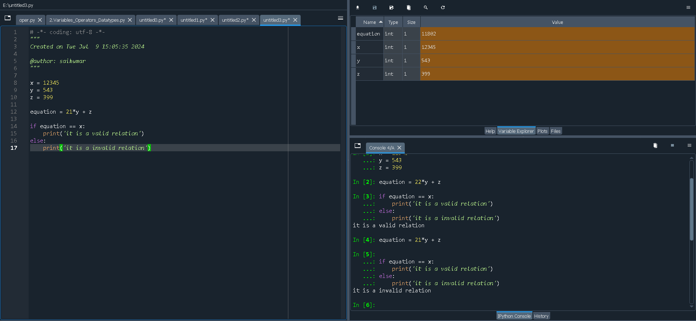

B. “When I divide 5 with 3, I get 1. But when I divide -5 with 3, I get -2”—How would you justify it?

In Python (and many other programming languages):

**1.Integer Division (‘//’)**: This operation returns the floor of the division, which means it rounds down to the nearest integer.

**2.Floor Division (‘//’)**: This operation performs division and rounds down to the nearest integer.

### 1. Dividing 5 by 3:

When you divide 5 by 3 in Python:

5 // 3

* Result: 1

This is because 5 divided by 3 is approximately 1.666..., and // operator rounds down to the nearest integer, which is 1.

### 2. Dividing -5 by 3:

When you divide -5 by 3 in Python:

-5 // 3

* Result: -2

This might seem counterintuitive at first glance. Here's the reasoning:

* -5 / 3 in decimal form is approximately -1.666....
* However, // operator rounds down towards negative infinity. This means it gives the largest integer less than or equal to the result of the division.

To understand why -5 // 3 gives -2:

* -1.666... rounds down to -2, as -2 is less than -1.666... and the nearest integer towards negative infinity.

2. a=5,b=3,c=10.. What will be the output of the following:

A. a/=b

a = a / b

a = 5 / 3

a = 1.666666666666667

B. c*=5

c = c * 5

c = 10 * 5

c = 50

1. A. How to check the presence of an alphabet ‘S’ in the word “Data Science” .

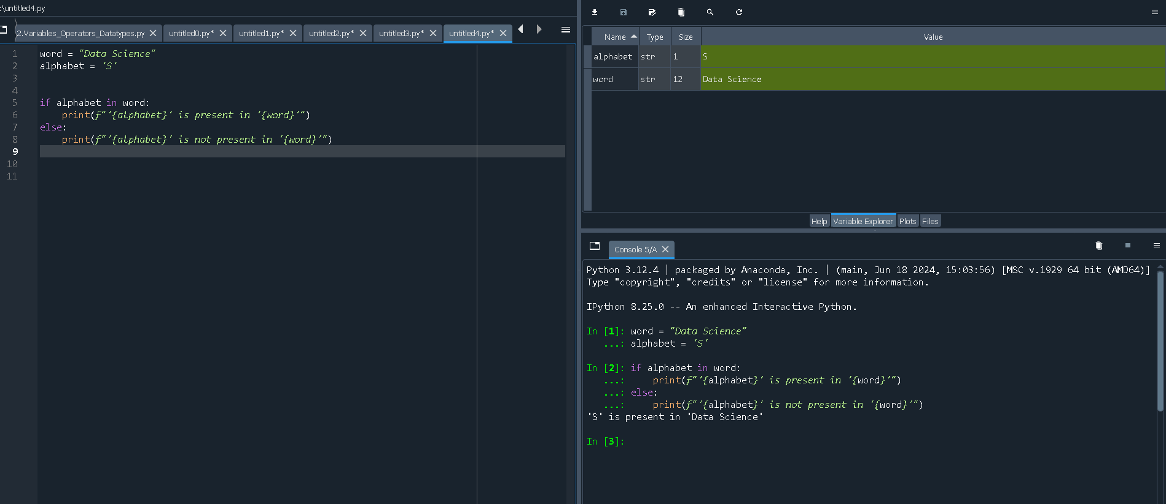

B. How can you obtain 64 by using numbers 4 and 3 .

result = 4 ** 3

print(result)

**Variables**

**Please implement by using Python**

1. What will be the output of the following (can/cannot):
2. Age1=5

Age1=5

Valid variable name.

Starts with a letter(`A`)

Followed by letters (`g` and `e`) and a digit (`1`).

Result: valid

1. 5age=55

Invalid variable name

Starts with a digit(`5`)

Va riable names cannot start with a digit according to Python naming rules.

Result: Invalid

1. What will be the output of following (can/cannot):
2. Age_1=100

Valid variable name.

Starts with a letter (`A`) and includes an underscore (`_`).

Followed by letters `(g `and `e`) and a digit (`1`).

Result: **Valid**

1. age@1=100

Invalid variable name.

Contains a special character (`@`).

Python variable names cannot contain special characters like ` @`.

Result: **Invalid**

1. How can you delete variables in Python ?